The exact prompt I gave to AI:- Write a c program in which take exactly 10 integers from user input and store them in an array using a loop and also find minimun value,maximum value and arithmetic mean with float value with 2 decimal places and sort the array in ascending order using any sorting method and display the sorted list and also print whether the mean is closer to minimum, closer to maximum or exactly midway between them.

Before the correction : It was unable to give answer if we take all values similar.

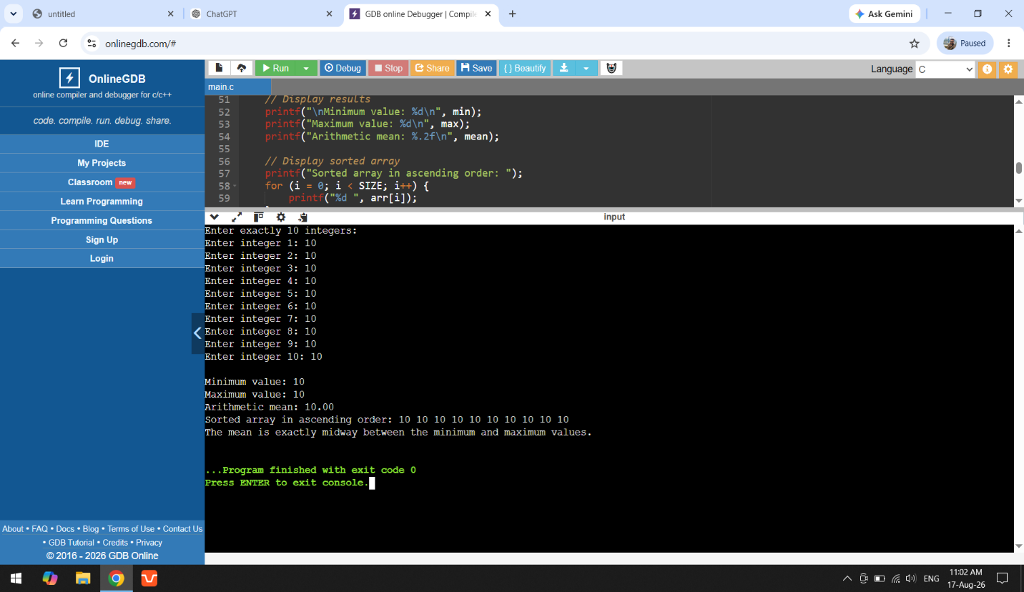

After the correction:- I modified the if statement to "All values are equal, so the mean is equal to both the minimum and maximum”

